DENTURE FIXATIVE

Q So what exactly are dentures?

A Dentures are worn to replace your natural teeth. They are usually made from lifelike resin teeth bonded to a plastic base. You will either have been fitted with a complete denture to replace all your teeth, or a partial denture. Partial dentures are usually held in place by clasps or metal clips, which fit around some of your remaining teeth.

Q Will anyone be able to tell I have dentures?

A Not easily. With today’s technology dentures can be made to look so natural that people can’t tell who’s wearing them. Your dentist has custom made your dentures to fit your mouth, so they’ll take on the character of your original teeth, leaving your appearance the same as before. The colour of the teeth is carefully selected, either to match your remaining teeth, or simply to look as natural as possible.

Q How easy is it to adjust to wearing them?

A While your dentures have been custom made, they may initially feel a little strange, or even rather a mouthful, however, rest assured that they only feel that way; you yourself will not look any different. You may also find you produce more saliva than normal but this should settle down soon enough. The time it takes to adjust to wearing new dentures is different for everyone, but you will soon learn how to eat, talk and smile as you would with natural teeth.

Q Will dentures change how I speak?

A Pronouncing certain words may require practice. Reading out loud and repeating difficult words will help. But over time you will adjust and get used to it, so don’t worry! Using a denture fixative will give you extra confidence with speaking.

Q Do I play a role in how successful my dentures are?

A Yes. Learning to eat with artificial teeth requires considerable skill and practice. This is because every person’s mouth has a different structure, which can affect the retention and stability of the denture. Also the level of suction which helps hold the denture in place, particularly the upper denture, will vary dependent upon the amount of saliva produced. Many denture wearers find the lower denture particularly difficult to manage at first. Experience will help, as will the use of a carefully selected denture fixative, which is a useful aid to assisting with denture retention and stability.

Q What about eating out?

A Once you get used to them, there is absolutely no reason why you should feel too restricted by your dentures. You will, with experience be able to enjoy your meals. At first it is probably a good idea to eat softer food, and to cut your food up into smaller pieces, just until you get used to your dentures. While you learn to use your dentures, it is also a good idea to take smaller mouthfuls and chew slowly; gradually you’ll get better as time goes on. After you put your food into your mouth, try to divide it in two, and then chew each half at the back of each side of your mouth. This even pressure on your dentures will stop them tipping and make them feel more stable. A lot of denture wearers avoid difficult foods like toffee, crust bread, nuts and apples because they are worried these might displace their dentures. However a fixative can help. There is a choice between flavoured and unflavoured fixative.

Q So what are denture fixatives?

A However well fitting your dentist has managed to make your dentures, they can never provide the same, strong biting surface as natural teeth. Using a denture fixative should dispel many of the doubts and fears you may have. Even if you have well fitting dentures a fixative will help in many ways, whether your dentures have just been fitted or you have had them a long time.

Q How do they work as an adhesive?

A Denture fixatives work by reacting with saliva in the mouth to develop adhesive properties. The ingredients then work together to hold the denture in place more firmly and reduce the wobble, so you can enjoy eating apples, crusty bread and other foods that you may otherwise avoid. A fixative can give you more confidence in public and social situations. You will feel better about eating, talking and even playing sports, especially swimming, which puts the suction of complete dentures at risk when water gets into the mouth.

Q How do fixatives work as a barrier?

A A fixative prevents any pips and seeds getting stuck between the dentures and your gums. It expands to fill any gaps and blocks access to these bits of food, so you can enjoy a wider range of foods.

Q How do fixatives act to increase your bite force?

A A fixative will increase your ability and confidence to bite into foods without dislodging your denture.

Q How does a fixative help prevent gum irritation?

A A fixative acts as a supporting layer between your dentures and your gums, to help prevent them rubbing. It also helps reduce the effects of any localised pressure making denture wearing more comfortable.

Q How do I use a denture fixative?

A Clean your denture, preferably by brushing with a denture toothpaste, and dry thoroughly. Apply denture fixative in short ½” strips. Experiment with position and quantity of the fixative for the best results. A good rule is “less is more”! Do not let the fixative ooze out. Small dots may be better. If oozing occurs use a little less. A good tip is to rinse your mouth before inserting your dentures for a quick hold. Press dentures firmly into place for several seconds. Wait several minutes before eating and drinking. The dentures can be removed easily when required. Brush gently with warm water to remove any remaining fixative.

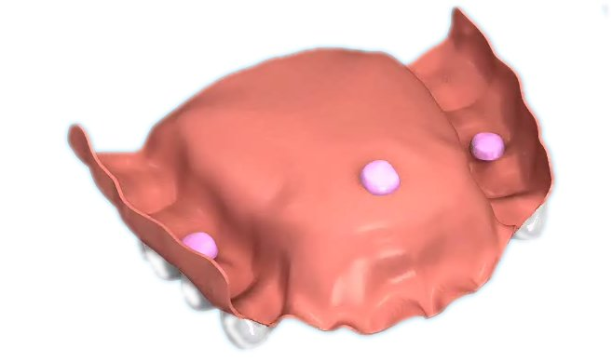

Q How do I take care of my dentures?

A Dentures need cleaning morning and night in the same way as your natural teeth. If you follow this same routine, you can not go far wrong. Pay particular attention to your gums, and any remaining teeth where they meet your dentures as plaque and debris builds up in these areas.

Q So how should dentures be cleaned?

A You should ask your dentist. When cleaning your dentures always remove them from your mouth beforehand to clean them properly. As a general guide remember that dentures are fragile and need to be handled carefully when out of the mouth. Cleaning them with a brush should be done over a basin filled with warm water, so that if you drop them the water will cushion the fall. The main purpose of cleaning is to remove the dental plaque, which builds up on dentures as well as teeth and can harm the gums. Brushing a denture will also remove any food particles stuck to it. The highly polished, easily cleaned new surface of dentures can be damaged by ordinary toothpastes, which can be too abrasive. There are special gentle denture cleaning toothpastes available which, will leave your dentures fresh and minty like a normal toothpaste but will not damage the surface. This brushing helps remove the plaque and debris, whereas soaking alone may not. If you have partial dentures, you should pay particular attention to cleaning your remaining teeth and follow a good oral hygiene routine.

Q What is soaking?

A Some people prefer to soak their dentures in a denture cleaning solution although it has been
proven that brushing with a denture cleaning toothpaste is
better than soaking alone. It is a personal choice, but
if you do soak them, use a known brand tablet or powder with luke warm water. If your dentures
have got metal parts, do not soak them for more than 10 minutes, and remember that continued soaking in boiling water can bleach or discolour your dentures. Most soaking brands recommend brushing as well as soaking to ensure debris and plaque are physically removed.

Q Do I still need to visit my dentist?

A Yes. Your dentures are made from materials that are softer than your natural teeth, so they will eventually need replacing. Also your mouth changes shape after your teeth have been removed, and even losing weight can change the shape of your mouth. So to make sure that your dentures continue to fit properly it is important that you visit your dentist at least once a year to have them checked. If you have partial dentures you should visit your dentist every six months.

